Exploring the Structure of Biomolecules with Interactive Models

Proteins are the complex molecular machines responsible for carrying out nearly every job in your body's cells. Each protein is made up of a long chain of molecules called amino acids. The basic structure of an amino acid is pictured below.
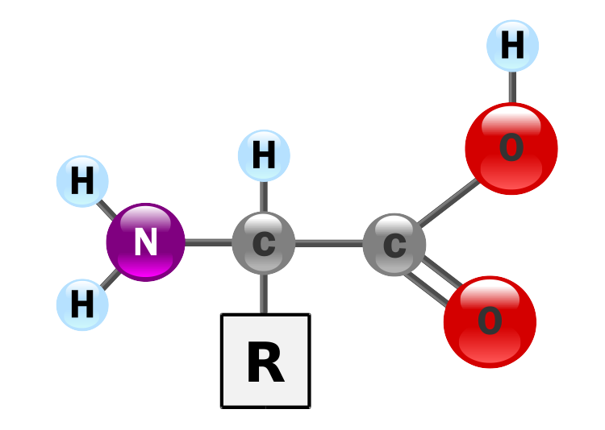

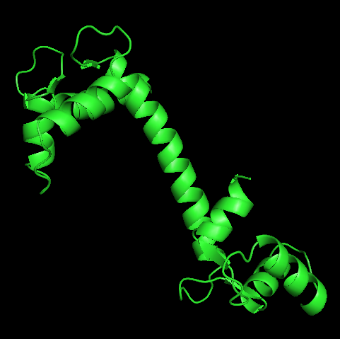
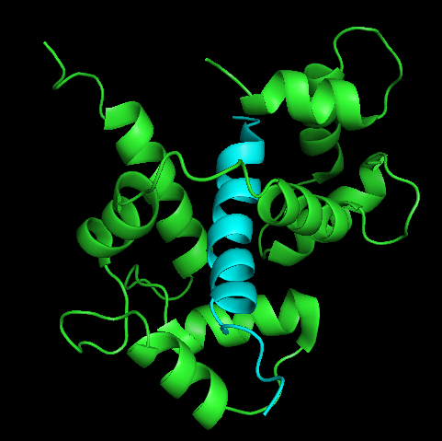
Chains of amino acids are linked through the nitrogen atom of the left side and the carbon atom on the right side. These chains can grow to be thousands of amino acids long and fold into complex shapes which allow proteins to perform their functions. For example, the protein pictured below in green is called calmodulin. It controls other proteins by binding to them. The sequence shows how calmodulin's structure, which includes a long skinny core between two thicker ends, allows it to wrap around and bind to one of its target proteins (called an SK potassium channel), which is shown in blue.

Scientists are still not sure how proteins so reliably fold into their functional shapes. However, we are learning more about this process every day. One active area of biology is concerned with figuring out how proteins are folded and exploring their folded structures to better understand both the process of folding and the manner in which proteins do their jobs. Many protein structures have been uploaded to the Protein DataBank by scientists. Its web address is http://www.rcsb.org.

- First, download SwissPDB viewer. You will need this program to view protein structures. The program is available at http://spdbv.vital-it.ch/.
- Each structure in the Protein DataBank is identified by a unique 4-character ID. Go to the Protein DataBank and download the following structures: 1BNA, 1CLL, and 1DMO.
- Open 1BNA with SwissPDB viewer.
- Describe the molecule. Does it look familiar?
- Like all proteins, the 1BNA structure is made up of a sequence of amino acids. Can you identify some of the amino acids present in the structure?
- Hydrogen bonding is very important to the stability of biomolecules. SwissPDB Viewer has a tool that will show you where hydrogen bonds are likely to occur. You can access it by selecting “Tools > Compute H-bonds.” Describe the location of the hydrogen bonds. How do you think they affect the structure of the molecule.
- 1CLL and 1DMO are both structures of the calmodulin protein we mentioned earlier. Calmodulin is sensitive to the concentration of calcium. In the presence of calcium, calmodulin changes shape. 1CLL shows calmodulin the the presence of calcium and 1DMO shows calmodulin without calcium.
- Compare the structures of 1CLL and 1DMO. How are they similar? How are they different?
- When calcium is around, calmodulin grabs and holds on to four calcium atoms. These calcium atoms change the shape of the protein. Can you figure out where calmodulin is holding the calcium atoms in structure 1CLL?
- Based on your examination in the previous step, which calmodulin structure (calcium or no calcium) is pictured in the figure above?
- Based on all of your observations, is calmodulin more likely to bind to another protein in the presence of or in the absence of calcium? Explain your reasoning.

