Predicting Infrared Spectroscopic Signatures with Hooke's Law

Chemists and physicists use infrared spectroscopy to learn about how atoms and molecules are arranged in many different compounds. A typical infrared spectroscopy setup is shown as a schematic below:
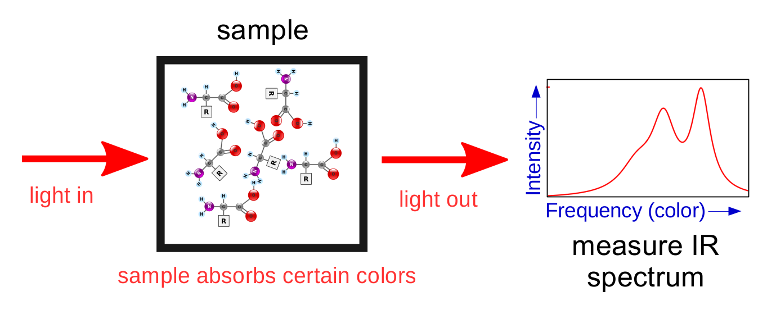

Since different molecules absorb different frequencies of light, it is possible to figure out what chemicals are in a sample simply by seeing what colors of light are absorbed.

Complex molecules can be subdivided into smaller parts called “functional groups.” Functional groups are collections of the same atoms that show up across different molecules. Since a particular functional group will absorb roughly the same frequencies of light no matter which molecule it is a part of, scientists can use infrared spectroscopy to figure out how a molecule is arranged.
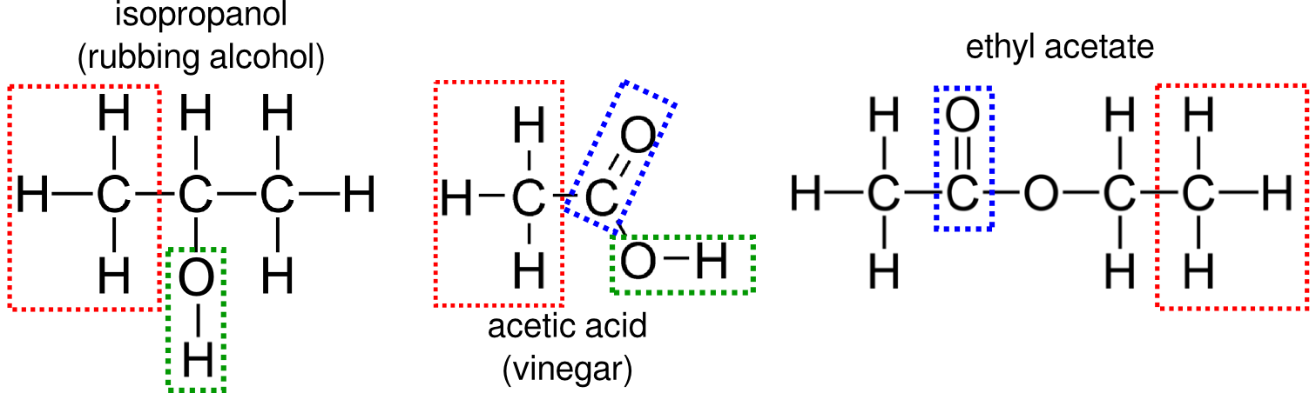

It is possible to approximately predict how simple, two-atom functional groups (like the C=O and O-H groups shown above) will absorb infrared light. Infrared absorptions are caused when a photon of light hits a functional group and causes it to vibrate. We can treat simple functional groups like masses connected by springs and use an equation derived from Hooke's Law to predict their vibrational absorptions:

In this equation, v is the approximate frequency of absorption (in a spectroscopic unit called “wavenumbers” or cm⁻¹), k is the spring constant of the functional group's molecular bond (in units of dynes per centimeter), and u is the reduced mass of the functional group. The reduced mass is calculated using the equation:

where m₁ is the mass of one atom in the functional group and m₂ is the mass of the other atom in the functional group. Values for k are given in the following table:

Bond | k (dyne per cm)
Single (-) | 5 x 10⁵
Double (=) | 10 x 10⁵
Triple (≡) | 15 x 10⁵

Now, let's make some predictions about infrared spectroscopy!

- Consult a periodic table, your textbook, or a reliable web site for the atomic masses (in amu) of hydrogen, carbon, nitrogen, oxygen, and other atoms you think might be important.
- Calculate a table of functional groups and the infrared absorptions you expect them to make. Remember to calculate the reduced mass using the right amu values for each atom, and to use the correct spring constant. Both the atoms and the bond type matter in infrared spectroscopy!
- What trends do you notice in your calculations? How do changes to atomic masses seem to affect the predicted absorption frequency? What about changes to the spring constant?
- Now that you have calculated some absorptions, try checking your calculations against real infrared spectra. You can find spectra by molecule name on the National Institute for Science and Technology (NIST) website at http://webbook.nist.gov/chemistry/. You can try starting with the molecules shown on the first page of this activity. Other interesting molecules to check out include formaldehyde, methanol, dimethyl ether, and dimethyl sulfoxide. Remember that your calculations are approximate!
- What differences do you notice between your calculations and actual infrared spectra? What do you think might be the cause for these differences?
- Now, go back to your functional group calculation table. At first, we only considered functional groups with two atoms. What if we group some atoms together and treat them as a single atom to calculate reduced mass? For example, the red-outlined CH₃ groups on the first page could be grouped together to give a CH₃-C functional group.

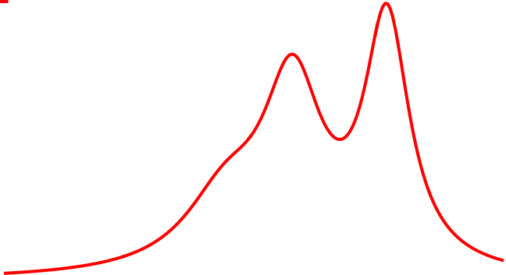
In addition to telling scientists what molecules are present in a sample, infrared spectroscopy can also provide information about how molecules are interacting. A weak kind of bonding called “hydrogen bonding” can occur in water and other liquids. When hydrogen bonding occurs, an extra H-atom becomes weakly attached to one atom of a functional group. How do you think this affects the functional group's infrared absorption? Why?

Frequency (color)
Intensity

To the left is an infrared spectrum for a single C=O functional group dissolved in a hydrogen bonding solvent. Even though only one functional group is present, you can see that there are three peaks (two strong peaks and one “hump” on the left side”). Form a hypothesis for what is happening.

